Market – SPA Application – JS Apps Exam
You are assigned to implement a Shopping Web front-end application (SPA) using HTML5, JavaScript, AJAX, REST and JSON with cloud-based backend (Kinvey). The app keeps users and products. Users can register, login, view the products, purchase products (adding them to their cart), view their cart, discard products (from their cart) and logout.
Using libraries like jQuery and React is allowed but is not obligatory.

Create a Kinvey REST Service to Hold Users and Products
Register at Kinvey.com and create an application to keep your data in the cloud.
In the Users collection, import the provided JSON file with sample users to get started with template data. In the Kinvey Console, select Users from the navigation of the left, click Settings in the upper right then scroll down to the Import section:
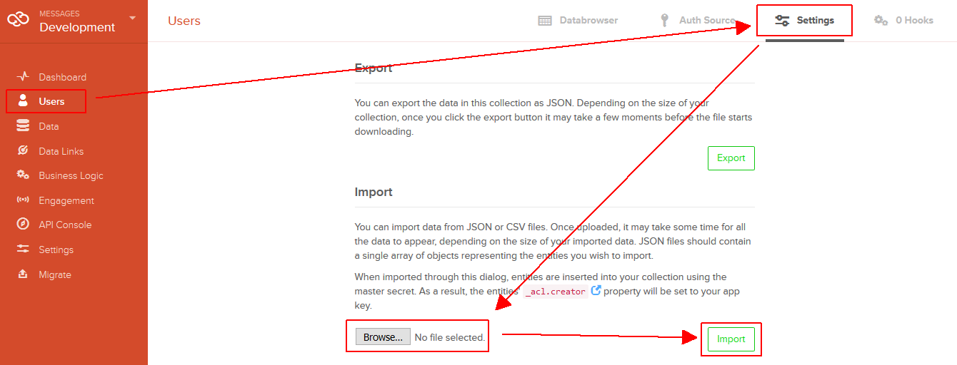
Create a collection products(name, description, price) to hold the products. All the fields will hold text values, except the price - it will hold a numeric value. The “_kmd.lmt” field is automatically created by Kinvey and will hold a date and time in the traditional for JavaScript dates ISO8601 format returned by Date.toJSON().
Create a new collection and import the provided JSON file with sample products like shown below:
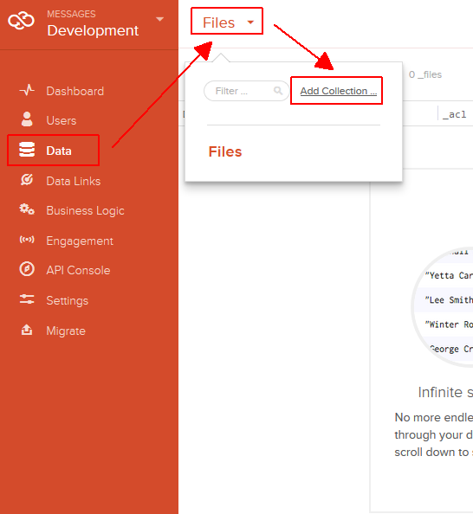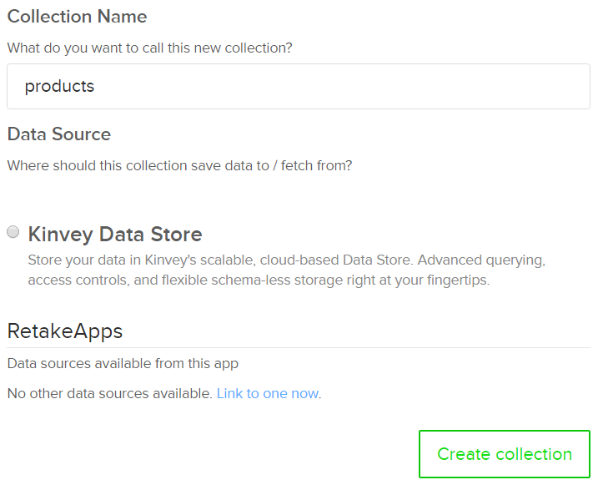
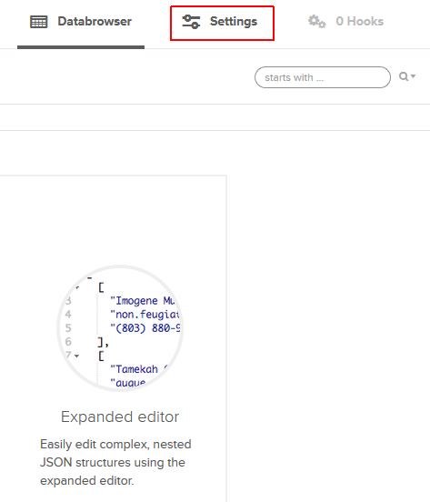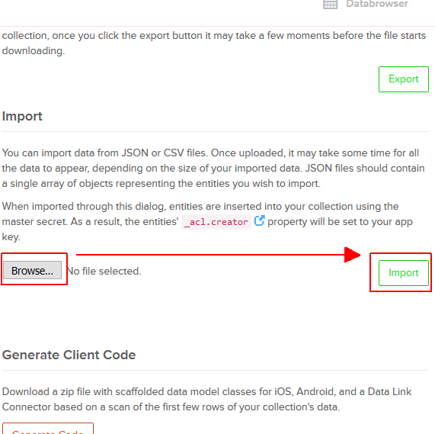
Kinvey will automatically create REST services to access your data.

Test the Kinvey REST Services
Using Postman or other HTTP client tool (you can use Kinvey’s built-in API Console), test the REST service endpoints:

User Registration (Sign Up)
POST https://baas.kinvey.com/user/app_id/
Request headers | Authorization: Basic base64(app_id:app_secret)  Content-Type: application/json
Request body | {  "username": "new_user",  "password": "pass123",  "name": "New User"  }
Response  201 Created | {  "_id": "583f53bde004a9a90983f1b7",  "username": "new_user",  "password": "pass123",  "name": "New User",  …  }
Error response  409 Conflict | { "error": "UserAlreadyExists", "description": "This username is already taken. Please retry your request with a different username", "debug": "" }
Error response  401 Unauthorized | { "error": "InvalidCredentials", "description": "Invalid credentials. Please retry your request with correct credentials", "debug": "" }
The request needs “Basic” authentication. Use the Kinvey app_id and Kinvey app_secret as credentials.
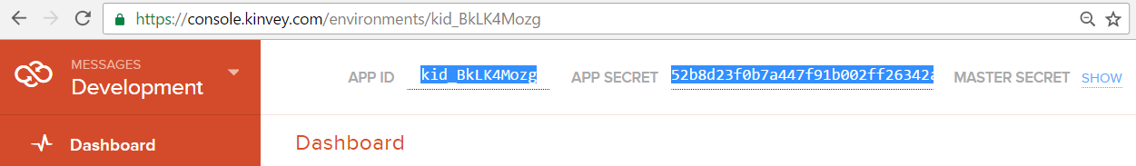

User Login
POST https://baas.kinvey.com/user/app_id/login
Request headers | Authorization: Basic base64(app_id:app_secret)  Content-Type: application/json
Request body | {  "username": "new_user",  "password": "pass123"  }
Response  200 OK | {  "_id": "583f53bde004a9a90983f1b7",  "username": "new_user",  "name": "New User",  "_kmd": {  "authtoken": "8e6471bc-3712-4cfb-b92e-50e62a0c80….Duj5fHdM /7XHIe6KdY="  …  },  …  }
Error response  401 Unauthorized | { "error": "InvalidCredentials", "description": "Invalid credentials. Please retry your request with correct credentials", "debug": "" }
Successful login returns an “authtoken” which is later used to authenticate the CRUD operations.

User Logout
POST https://baas.kinvey.com/user/app_id/_logout
Request headers | Authorization: Kinvey authtoken
Response
204 No Content
Error response  401 Unauthorized | { "error": "InvalidCredentials", "description": "Invalid credentials. Please retry your request with correct credentials", "debug": "" }
To logout, you need to provide the “authtoken” given by login / register as “Kinvey” authorization header.

Get All Products (Shop)
GET https://baas.kinvey.com/appdata/app_id/products
Request headers | Authorization: Kinvey authtoken
Response  200 OK | [  {  "_id": "5858699d4ad56c1314c48e96",  "name": "Apple",  "description": "An apple a day keeps the doctor away.",  "price": 0.5,  "_acl": {"creator": "kid_S1Oq7JU4g"},  "_kmd": {"lmt": "2016-12-19T23:13:33.195Z"…}  },  {  "_id": "585876b24ad56c1314c50eef",  "name": "Kroasan",  "description": "Chichipipikakao",  "price": 1.1,  "_acl": {"creator": "kid_S1Oq7JU4g"},  "_kmd": {"lmt": "2016-12-20T00:09:22.624Z"…}  }, ...  ]
Error response  401 Unauthorized | { "error": "InvalidCredentials", "description": "Invalid credentials. Please retry your request with correct credentials", "debug": "" }

List Particular User
GET https://baas.kinvey.com/user/app_id/user_Id
Request headers | Authorization: Kinvey authtoken
Response  200 OK | [  {  "_id": "5858679fe12ae039723fb628",  "username": "pesho",  "name": "Pesho Peshov",  "_acl": {  "creator": "5858679fe12ae039723fb628"  },  "_kmd": {  "lmt": "2016-12-20T01:09:51.514Z",  "ect": "2016-12-19T23:05:03.691Z"  },  "cart": {}  }  ]

NOTE: The cart is kept in the Users collection. Every user has a cart field which corresponds to his cart. The cart is an object – initally empty. You will see how it is used later.

Update Particular User
PUT https://baas.kinvey.com/user/app_id/user_Id
Request headers | Authorization: Kinvey authtoken
Request body | {  "_id": "5858679fe12ae039723fb628",  "username": "pesho",  "name": "Pesho Peshov",  "_acl": {  "creator": "5858679fe12ae039723fb628"  },  "_kmd": {  "lmt": "2016-12-20T01:09:51.514Z",  "ect": "2016-12-19T23:05:03.691Z"  },  "cart": {  "585876e5b91c66ad2607e865": {  "quantity": "1",  "product": {  "name": "Toilet Paper",  "description": "IsSoft",  "price": "4.10"  }  }  }  }
Response  200 OK | [  {  "_id": "5858679fe12ae039723fb628",  "username": "pesho",  "name": "Pesho Peshov",  "_acl": {  "creator": "5858679fe12ae039723fb628"  },  "_kmd": {  "lmt": "2016-12-20T01:09:51.514Z",  "ect": "2016-12-19T23:05:03.691Z"  },  "cart": {  "585876e5b91c66ad2607e865": {  "quantity": "1",  "product": {  "name": "Toilet Paper",  "description": "IsSoft",  "price": "4.10"  }  }  }  }  ]

NOTE: The PUT request, updates the object in the back-end with whatever you send as a body. Note that you can send everything, but whatever you send, will REPLACE whatever is currently on the back-end at the current id.
Upon updating, make sure you first send a GET request, to get the current entity, and change the data you receive, for example the cart, and then send the same data back. Otherwise you might break the back-end data.

Market – HTML and CSS
You аre given the Web design of the Market application as HTML + CSS files.
- Initially all views and forms are shown by the HTML. Your application may hide by CSS (display: none) or delete from the DOM all unneeded elements or just display the views it needs to display.
- You may render the views / forms / components with React, jQuery, Mustache or another UI library.
Important: don’t change the elements’ class name and id. Don’t rename form fields / link names / ids.

Market Client-Side Web Application
Design and implement a client-side front-end app (SPA) for managing the products and carts of users. Implement the functionality described below.

Navigation System
Implement a navigation system for the app: navigation links should correctly change the current screen (view).
- Clicking on the links in the top navigation bar should display the view behind the link (views are sections in the HTML code).
- Your application may hide by CSS (display: none) or delete from the DOM all unneeded elements or just display the views it needs to display.
5 score

Home Screen
When no user is logged in, the app should display the "Home" screen holding a welcome message + three links: [Home], [Login] and [Register].
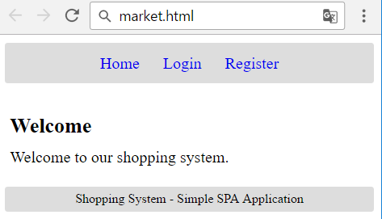
5 score

Register User Screen
By given username + password + name the app should register a new user in the system.
- After a successful registration, a notification message “User registration successful.” should be displayed and the user home screen should be displayed.
- In case of error, an appropriate error message should be displayed and the user should be able to try to register again.
- Form validation is already implemented in the HTML, so you don’t need to add it.
- Keep the user session data in the browser’s session storage.
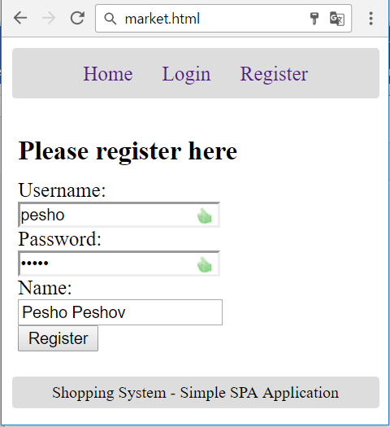
10 score

Login User Screen
By given username and password the app should be able to login an existing user.
- After a successful login, a notification message “Login successful.” should be displayed and the user home screen should be displayed.
- In case of error, an appropriate error message should be displayed and the user should be able to fill the login form again.
- Form validation is already implemented in the HTML, so you don’t need to add it.
- Keep the user session data in the browser’s session storage.
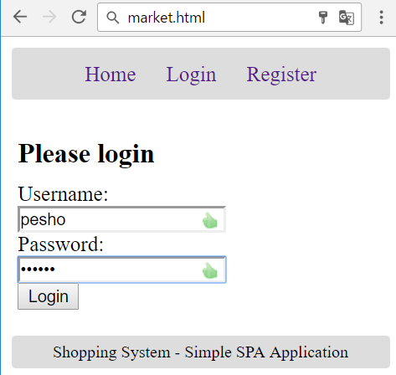
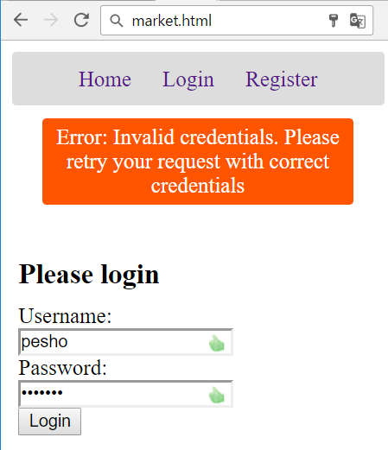
5 score

Logout
Successfully logged in user should be able to logout from the app.
- After a successful logout, a notification message “Logout successful.” should be displayed.
- After successful logout, the Home screen should be shown.
- The “logout” REST service at the back-end should be obligatory called at logout.
- All local information in the browser (user session data) about the current user should be deleted.
5 score

User Home Screen
After successful login, the app should display the user's home screen.
- It should hold a message “Welcome, ” + the username of the current user.
- At the top navigation bar display the navigation links [Home], [Shop], [Cart] and [Logout] + “Welcome, {username}”.
- At the main view area display navigation boxes [Shop], [Cart].
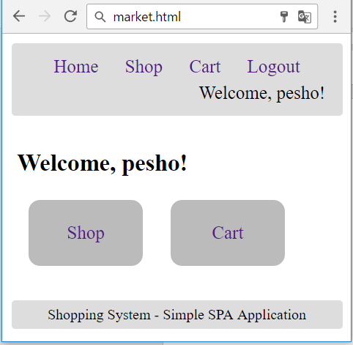
- Ensure you handle properly all HTML special characters, e.g. the username could be "<pesho><br>".
5 score

Shop Products Screen
Successfully logged users after clicking the [Shop] link should be able to view all products.
- The products should be listed in the format as shown in the Web design (see the screenshot below).
- In case of error (e.g. Internet connection lost), an error message should be displayed.
- Display [Purchase] button for each product in the shop. The button will purchase the product, adding it to the user’s cart.
- Thought this case is quite impossible… In case of no products, display an empty table (header row only).
- All prices should be rounded, the default way (0.505 == 0.51, 0.504 == 0.50) to the second digit after the decimal point, and printed the same way.
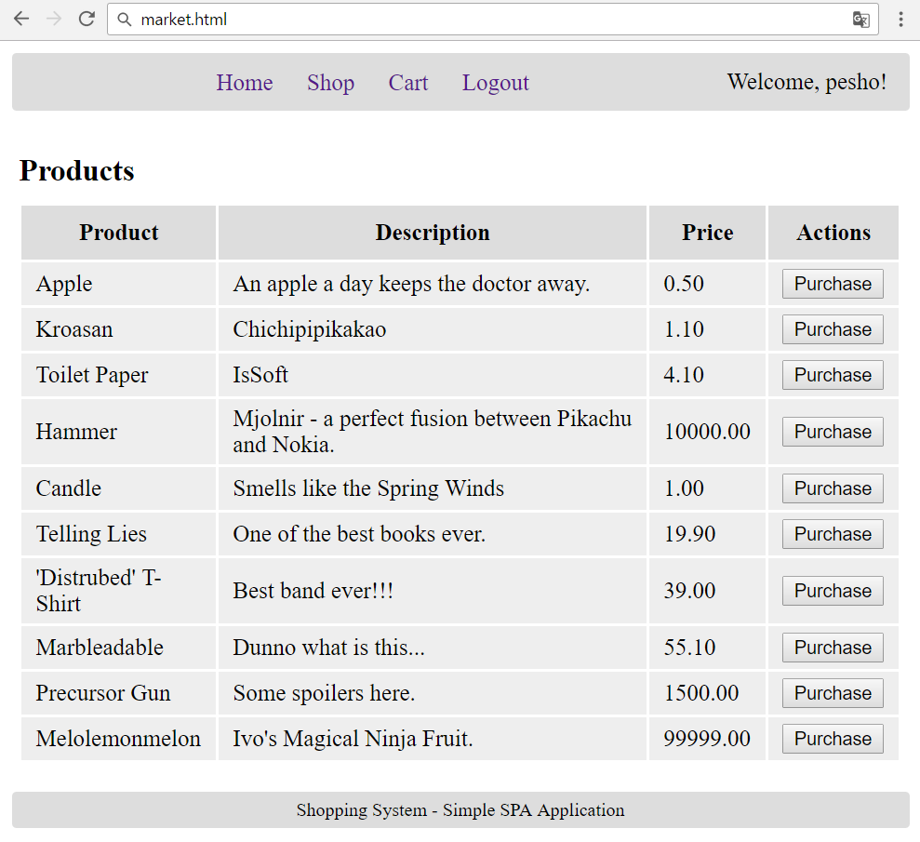
15 score

Cart Products Screen
The Cart functionality is quite simple for implementing. When you must store products in the cart, upon purchase... You should store in the cart field, which is an object, the id of the particular product, as a key (property) and the product’s quantity, and product data, as a value (of the property). In the end it would look like this.
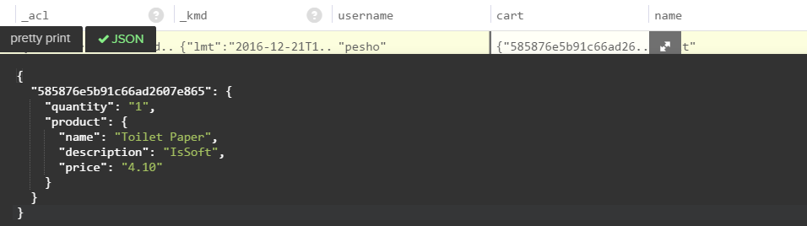
If you have multiple products, they are to be stored, each with its id (as the key), and the quantity and product data as an object (as the value). You have been given several users with multiple products in their carts. Use them as test data.
That is why you were given an Update end-point. So you could update the cart of a user, adding or removing a property from the cart object, or just increasing its quantity.
Successfully logged users after clicking the [Cart] link should be able to view all products, purchased by the current user, i.e. products which are currently in the user’s cart.
- The products should be listed as shown in the Web design (see the screenshot below).
- In case of error (e.g. Internet connection lost), an error message should be displayed.
- Display [Discard] button for each product in the cart. The button will discard the product, removing it from the user’s cart.
- In case of no products, display an empty table (header row only).
- All prices should be rounded, the default way (0.505 == 0.51, 0.504 == 0.50) to the second digit after the decimal point, and printed the same way.
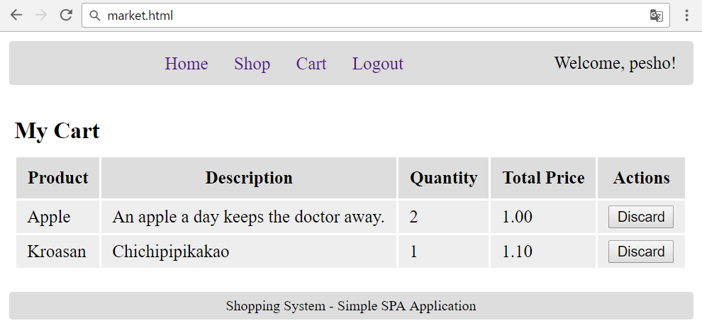
20 score

Purchase Product
Successfully logged in users should be able to purchase products by choosing a product, from the Shop products, and clicking the [Purchase] button.
- After a successful product purchase, a notification message “Product purchased.” should be displayed and the cart (user’s cart) should be shown.
- In case of error, an appropriate error message should be displayed.
- Users are allowed to purchase a product, more than once, which is why the Quantity parameter stays in the table of the Cart view. The Total Price should be equal to the product_price * quantity.
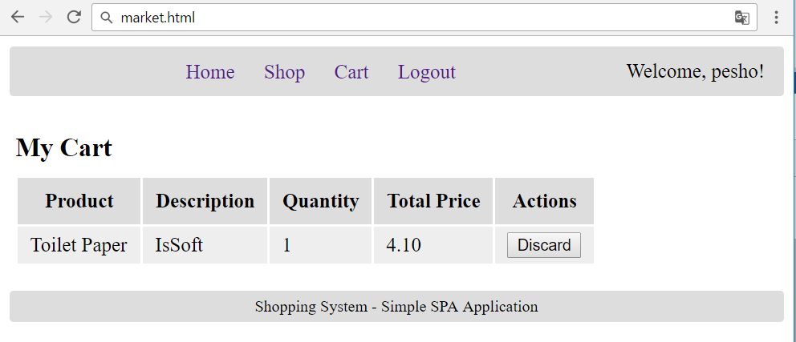
15 score

Discard Product
Successfully logged in users should be able to discard the products they purchased by clicking on the [Discard] button in the table of product in the Cart view.
- After successful product discard a notification message “Product discarded.” should be shown.
- In case of error (e.g. Internet connection lost / unauthorized request / missing product), an error message should be displayed.
- The Deletion, should delete the whole product, regardless of its quantity.
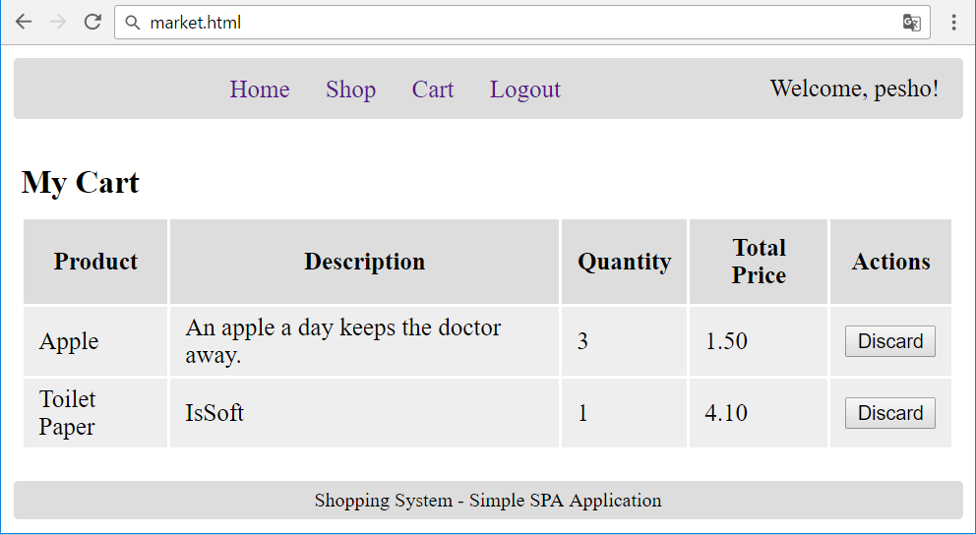
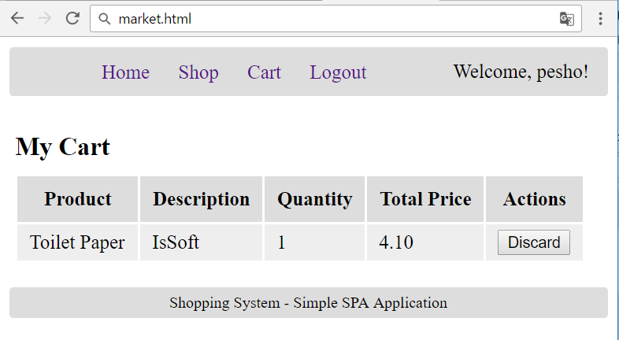
15 score

Notifications
The application should notify the users about the result of their actions.
- In case of successful action an informational (green) notification message should be shown, which disappears automatically after 3 seconds or manually when the user clicks it.
- In case of error, an error notification message (red) should be shown which disappears on user click.
- During the AJAX calls a loading notification message (blue) should be shown. It should disappear automatically as soon as the AJAX call is completed.
Good luck!

